IECEx/ATEX Certification Information Requirements

- BASIC INFORMATION (APPLICATION AND ORGANIZATION):
- Application form (provided by ExCB as a template).
Issued by the ExCB as a template; already received.
Status: Template received from the ExCB.

- Manufacturer's business license/company registration certificate.
The Manufacturer named in this application is PT Galaksi Megatama Indonesia, which holds the Indonesian industrial manufacturing business license (NIB) relevant to fabricating the equipment. PT LAPI Ganesha Utama (LGU) is the design and development authority responsible for the electronics, firmware, and system engineering of the GLD, working with the Institute of Technology Bandung as technical partner.

Particular | Value
Registered legal name | PT Galaksi Megatama Indonesia
Legal form | Perseroan Terbatas (limited liability company), National Private / PMDN, Small Enterprise scale
Business registration number (NIB) | 0510220020593, issued 5 Oct 2022 (OSS system)
Taxpayer ID (NPWP) | 61.126.496.1-427.000, registered 29 Sep 2022
Deed of establishment | Deed No. 52, 22 Sep 2022 (Notary Steffi Alphanie, S.H., M.Kn., Cilegon City)
Ministerial ratification | MOLHR Decree No. AHU-0067398.AH.01.01.Year 2022 (29 Sep 2022)
Registered (domicile) address | Plaza Summarecon Bekasi, Jl. Bulevar Ahmad Yani Kav. K.01, Level 7, Bekasi City, West Java 17143
Relevant KBLI (business scope) | 25119, 25120 (tanks/reservoirs/containers of metal, incl. pressurized gas cylinders), 28221, 25920

- Manufacturer's organizational chart and contact information.
The statutory Board of Directors and Board of Commissioners are known from the deed of establishment:

Position | Name
President Director | Nur Rohman
Director | Antonius Prasetyo
Commissioner | Crisa Andi Sujatmiko

- Address of manufacturing plant and brief introduction of production facilities.
Registered office and NIB-registered production sites of the Manufacturer, PT Galaksi Megatama Indonesia:

Site | Address / Role
Registered office | Plaza Summarecon Bekasi, Jl. Bulevar Ahmad Yani Kav. K.01, Level 7, Bekasi City, West Java
Production site 1 | Jl. Kp. Jatipilar, Cikarang Selatan, Bekasi Regency
Production site 2 | Jl. WR Supratman, Mustikajaya, Bekasi City
Electronics design/assembly (LGU) | Native EasyEDA/JLCPCB project; fabrication/assembly provider and its address to be confirmed in writing

- If applicable) ISO 9001 certificate, quality manual, and directory of procedure documents (for QAR/QAN review).
ISO 9001 certification is currently in progress, with the audit planned for October 2026. The certificate, quality manual, and procedure-document index are pending submission.
Status: Open — certification and supporting documents in progress.

- TECHNICAL DOCUMENTATION:
- Detailed product description;
The Gas Leak Detector (GLD) is an IoT-based, multi-sensor gas leak detection device designed for the early detection of flammable and process gases in oil & gas refinery environments (process units, tank farms, pipe racks, and storage/loading-unloading areas). This document addresses the GLD unit itself as the subject of the current IECEx/ATEX certification.
Functionally, the GLD integrates eight channels of metal-oxide semiconductor gas sensors (MQ series), an edge-AI microcontroller/processor (ESP32-S3), and a LoRa radio module (star-topology wireless transmission) within a single fixed-point unit installed at locations with gas-leak risk. An on-device AI gas-classification model runs directly on the unit so that detection decisions do not depend on a continuous connection to a central server. When gas concentration exceeds a defined threshold, the unit triggers a local alarm (an integrated visual/audible alarm module) and simultaneously transmits an alarm notification over the LoRa network to the operator dashboard.
The enclosure is designed for hazardous-area deployment at refinery sites, using metal materials (aluminum alloy and stainless steel) and mounted via a bracket to existing structures without drilling or welding.
The current production power configuration is continuous 24 VDC, supplied via an AC/DC adapter connected to the site electrical supply.
- Product name, model, and specification list;

Product name | Gas Leak Detector (GLD)
Model | GLD V2 (Version 2)
Manufacturer | PT LAPI Ganesha Utama
Technical development partner | Institute of Technology Bandung, IoT Laboratory & Physics Laboratory
Program owner | PT Pertamina Patra Niaga (initial deployment site: Refinery Unit IV, Cilacap)
Primary function | Acquisition of 8-channel gas sensor data and LoRa transmission
Microcontroller | ESP32-S3-WROOM-1U-N16R8
LoRa radio module | E22-900MM22S
Dimensions (L×W×H) | 200 × 90 × 290 mm
Enclosure material | Aluminum alloy + stainless steel

- Complete and clear functional description and technical parameters (electrical parameters, mechanical parameters, etc.);

Functional workflow (normal operating mode): sense → process → transmit. Each of the eight gas sensors continuously samples ambient conditions → data is normalized and classified by the on-device AI model (ESP32-S3) → the result is transmitted over the LoRa network (star-topology transmission) at a configurable interval, or immediately (event-driven) when an alarm condition is detected. Gas alarms are triggered through two parallel channels: a local visual/audible alarm module on the unit itself, and a push notification transmitted over the LoRa network to the dashboard.

Electrical Parameters — Node Sensor (GLD) :
PARAMETER | SPECIFICATION | STATUS | REMARKS
Main power input | 24 VDC | Final | Continuous power supply from a site AC/DC adapter.
AC/DC adapter input | 220 VAC, 50 Hz | Final | Compliant with the Indonesian national electrical grid standard (PLN).
AC/DC adapter output | 24 VDC | Final
Internal operating voltage | 5 VDC & 3.3 VDC | Final | 5 VDC for the MQ sensor/heater circuitry; 3.3 VDC for ESP32-S3 logic. Per-rail current not yet documented separately.
Maximum input current | ≈0.33 A @ 24 VDC | Final | Calculated from measured maximum power consumption (8 W) divided by 24 VDC.
Maximum power consumption | 8 W @ 24 VDC | Final | Applies to the continuous-power configuration.
Electrical protection (fuse, reverse polarity, overvoltage, overcurrent) | Designed-in 24 V input protection: resettable PTC fuses, a 33 V TVS on the 24 V input, and P-channel MOSFET input stages. | Final | Overcurrent protection, transient-voltage protection, and reverse-polarity/input-stage protection.

Sensor and Communication Parameters — Node Sensor (GLD):
PARAMETER | SPECIFICATION | STATUS | REMARKS
Gas sensors | MQ-2, MQ-3B, MQ-4, MQ-5, MQ-6, MQ-7B, MQ-8, MQ-135 (8 channels) | Final | Metal-oxide semiconductor sensors; sensing element directly exposed to ambient air.
Environmental sensor (temperature/humidity) | SHT40-AD1B-R2 (I2C) | Final | Auxiliary temperature/humidity input included in the primary hardware design.
Analog-to-digital converter | ADS1256IDBR | Final | 24-bit multi-channel analog acquisition for the 8 sensor channels; 30,000 SPS, firmware SPI clock 1.92 MHz.
Processing unit | ESP32-S3-WROOM-1U-N16R8 | Final | Certified under FCC (2AC7Z-ESPS3WROOM1U), TELEC, and CE (per Espressif data), RF/EMC certifications.
Communication module | LoRa, E22-900MM22S module | Final | Certified under CE, FCC, and RoHS (per Ebyte data), RF/EMC certifications.
Operating frequency | 920 MHz | Final | Star-topology transmission; within the regional 920–923 MHz ISM band (Indonesia).
Transmit power (firmware configuration) | 0-22 dBm | Final | The radio module supports up to 0 dBm to 22 dBm is an operational configuration.
Bandwidth / spreading factor / coding rate | 125 kHz / SF7 / CR 4/5 | Final | EMC parameter table and official product technical datasheet.
Antenna | 3 dBi | Final | External, omnidirectional, SMA male connector.
Modbus interface | Read-only Modbus RTU slave, 9600 bit/s 8N1, (THVD1410DR transceiver) | Final | Provides 8 read-only registers (device status word, classification result, confidence, power source, external power, LoRa transmission counter, node ID).

Mechanical Parameters — Node Sensor (GLD):
PARAMETER | SPECIFICATION | STATUS | REMARKS
Enclosure material | Aluminum alloy + stainless steel | Final | Combination of two separate materials, rather than a single blended alloy.
Dimensions (L × W × H) | 200 × 90 × 290 mm | Final | Length x Width x Height
Total weight | 2378 g | Final | Total Weight from PCB, Casing, Sensor
Mounting method | Bracket Plate | Final | Mounted to existing structures
Ingress protection (IP rating) | IP66 | Final | Completely protected against dust and resistant to powerful water jets from all directions. Suitable for outdoor
Cable entry (gland) | Plastic PG13.5 | Final | CE Cetrificate
Antenna mounting | SMA male connector | Final | External
Operating temperature | −20°C to +60°C | Final | Ambient temperature range (Ta)
Operating humidity | 5–95% | Final | non-condensing

- Clear product photos (overall and key components);

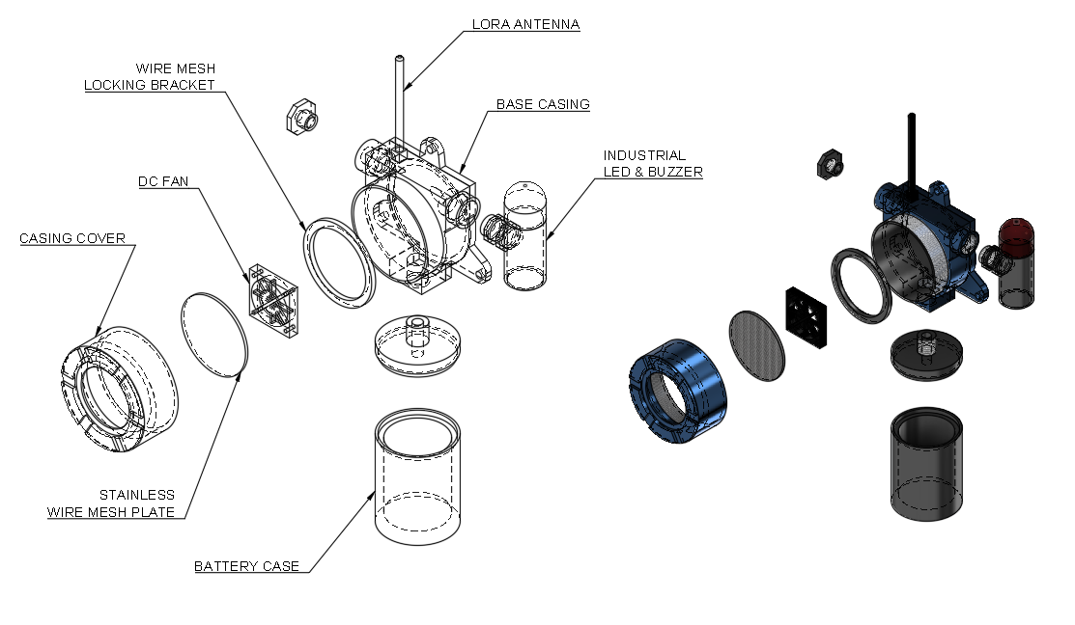
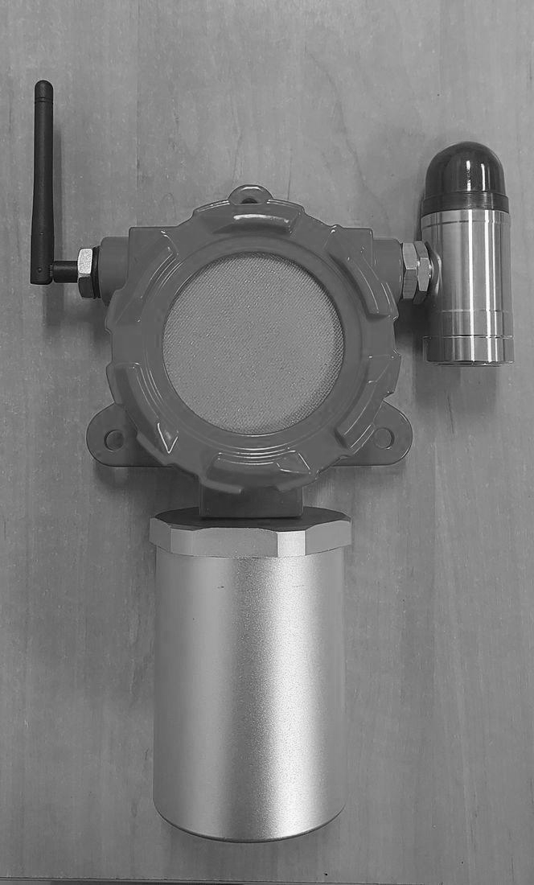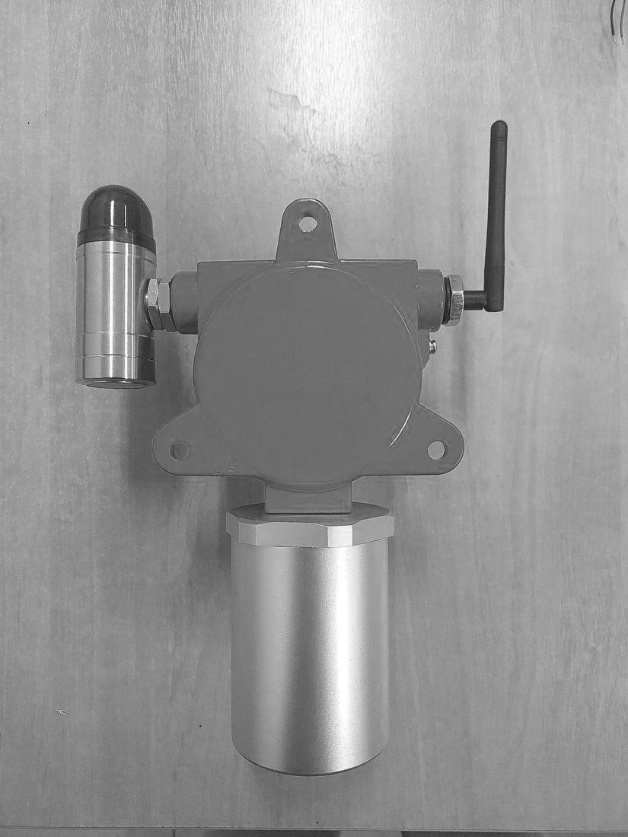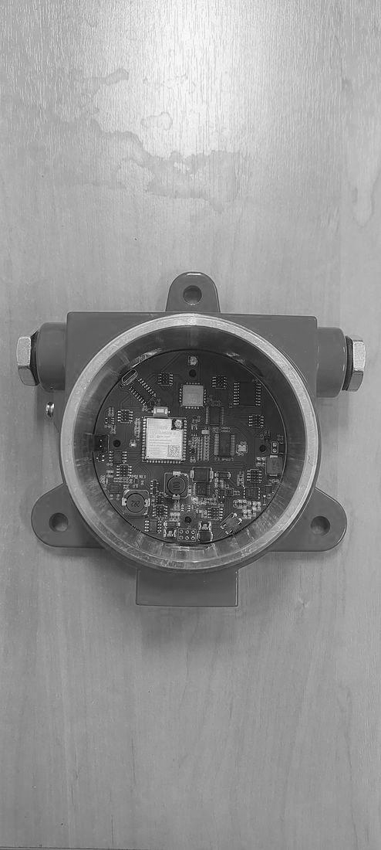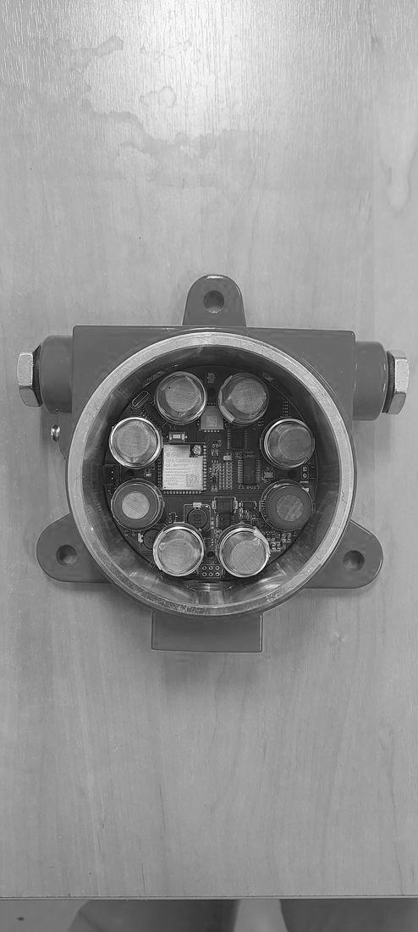
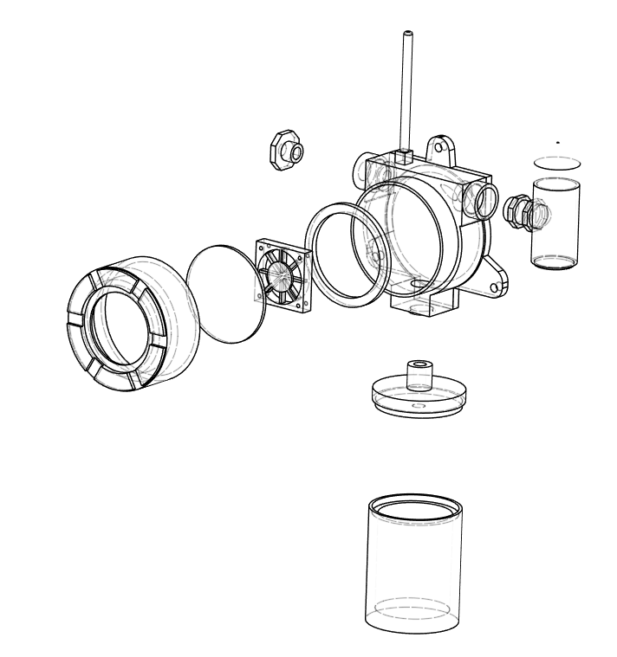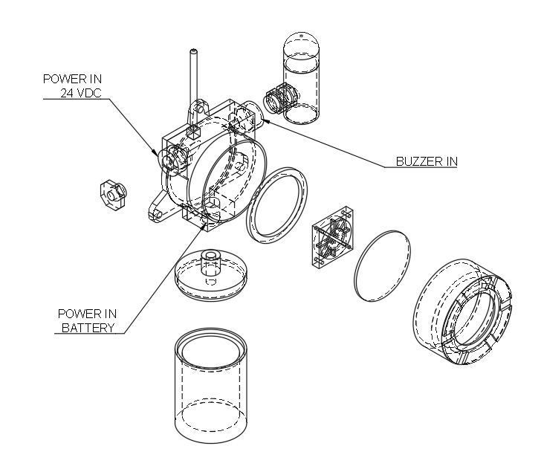
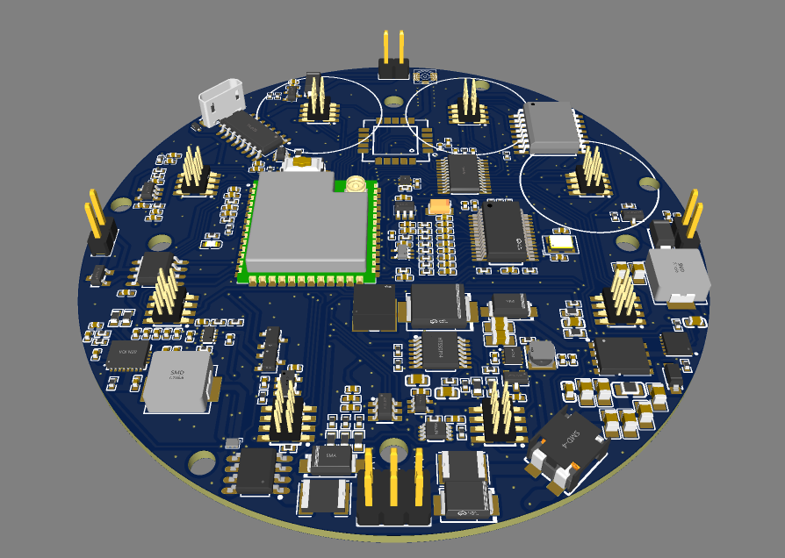
MOTHERBOARD PCB
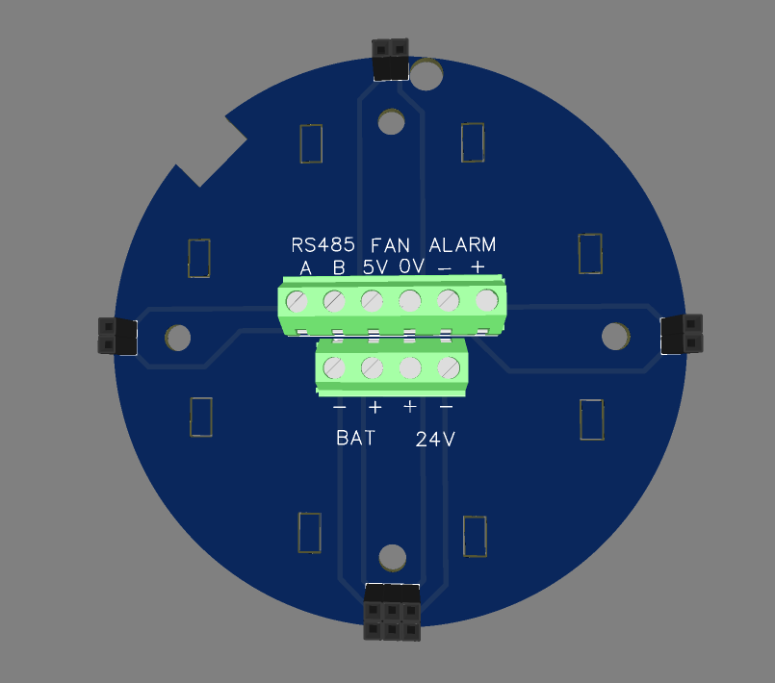
POWER IN
PCB COVER (TERMINAL MODULE)
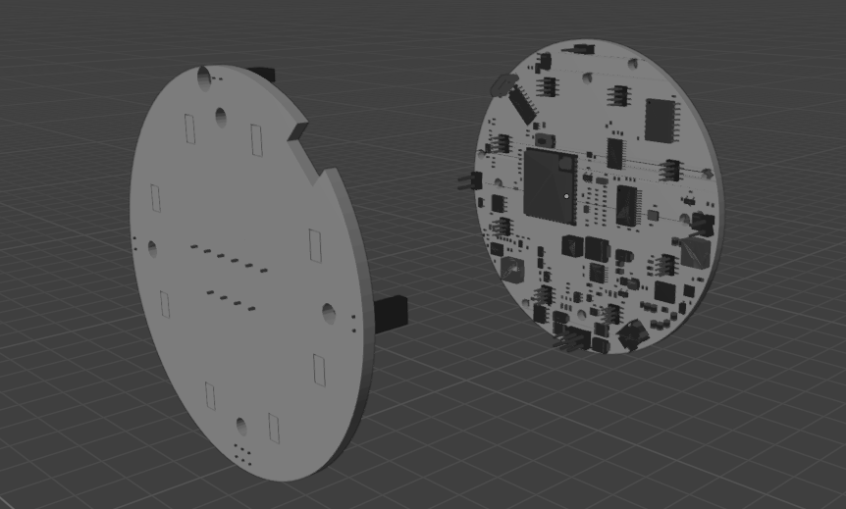
PCB COVER
MOTHERBOARD PCB

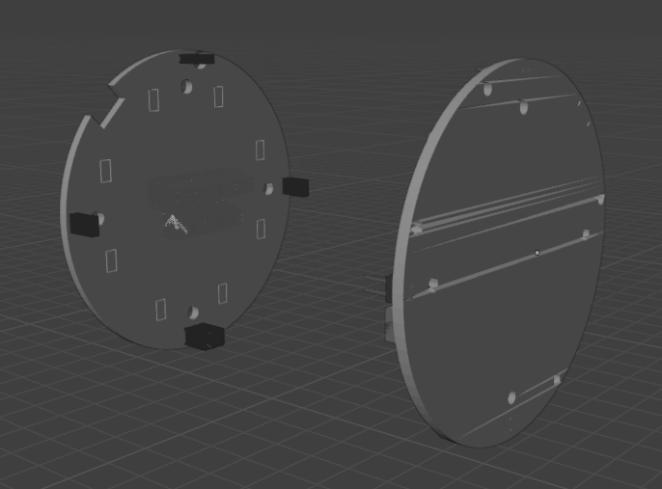
MOTHERBOARD PCB
INSIDE CLOSURE

MQ SENSORS TECHNICAL PARAMETERS

MQ-2
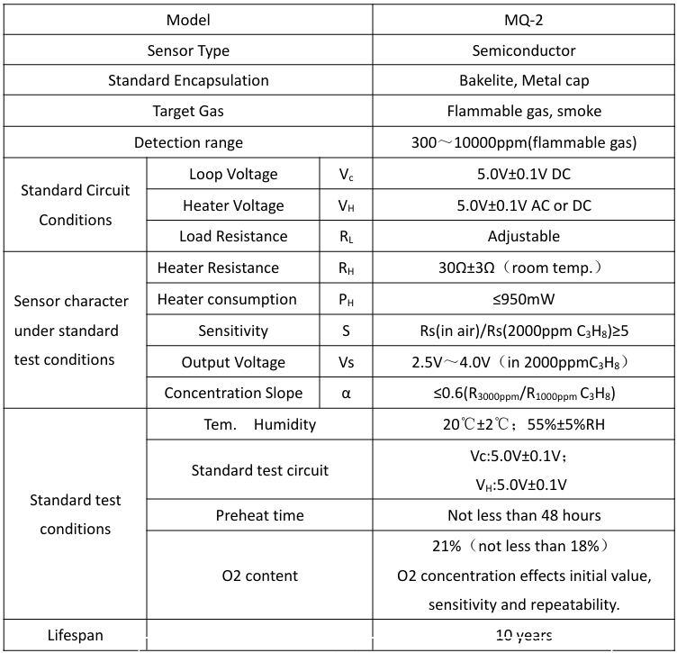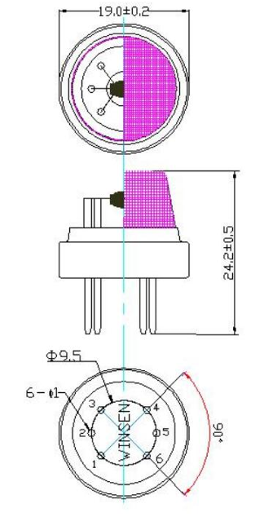

MQ-3
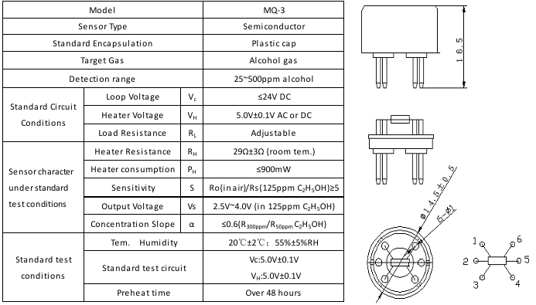

MQ-4
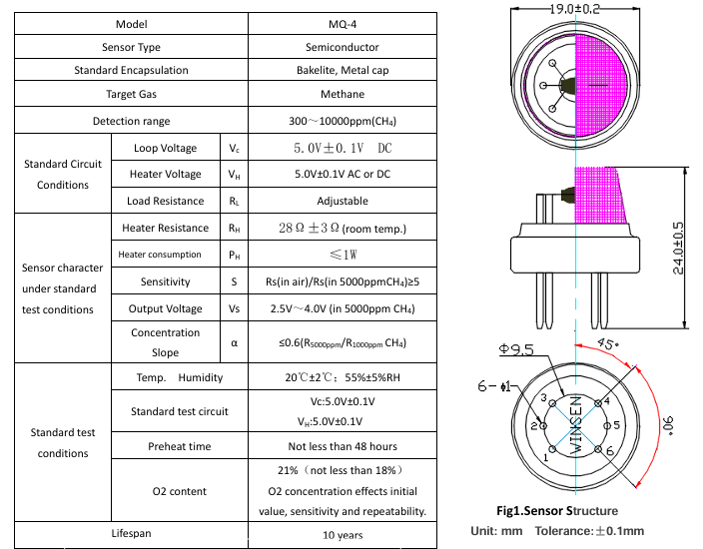

MQ-5
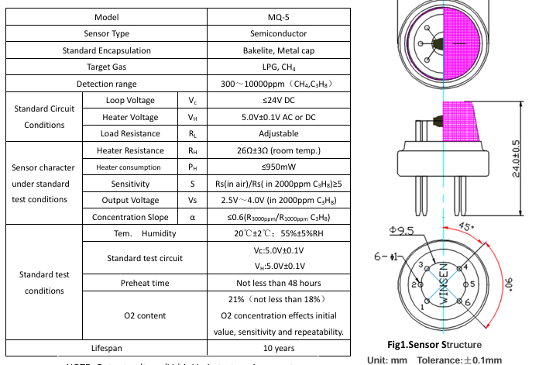

MQ-6
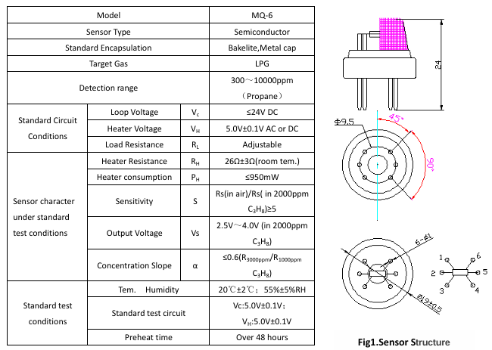

MQ-7
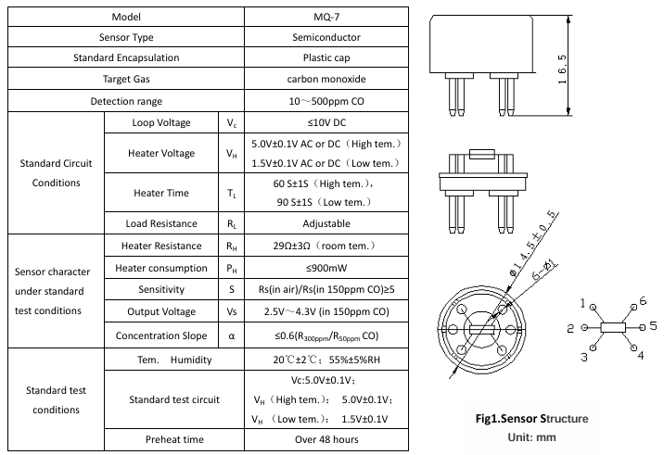

MQ-8
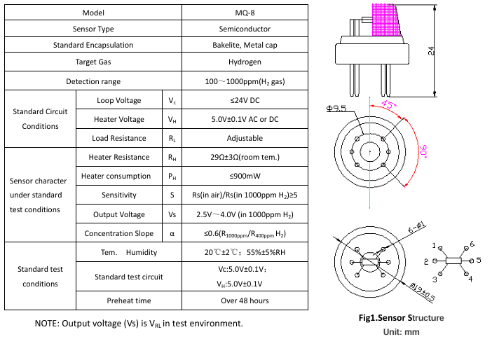

MQ-135
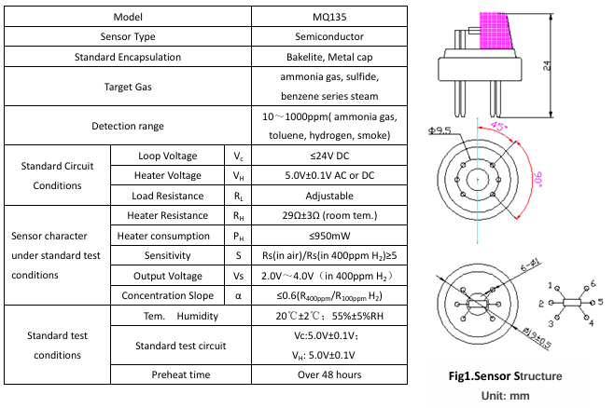

- Description of intended use and installation environment (e.g., gas group IIC/IIB/IIA if applicable, temperature group T1-T6, ambient temperature range, area classification 0/1/2 or 20/21/22);
The GLD is intended for continuous, fixed-point monitoring of flammable and toxic gas leaks in oil & gas refinery hazardous areas : process units, tank farms, pipe racks, and loading/unloading areas.
Parameter | Value | Status | Rationale / Remarks
Equipment Group | II (surface industries) | Final | —
Equipment Category / EPL | 2G / Gb | Proposed by the project team — pending ExCB confirmation | Aligned with the target certification scheme stated in the project dashboard/proposal.
Gas Group | IIC | Proposed by the project team — pending ExCB confirmation | The MQ-8 sensor specified in Section 2.3 is intended for hydrogen (H₂) detection. Hydrogen is associated with Gas Group IIC, which is the most stringent gas subgroup. Equipment rated for IIC is also suitable for IIB and IIA gas groups; therefore, it provides coverage for the other target gases, subject to confirmation of the complete gas list and certification conditions. Typical examples include LPG/methane (IIA) and hydrogen sulphide/ammonia (IIB). eaton+1
Temperature Class | T4 (≤ 135 °C) | Proposed by the project team — pending hot-spot calculation and test results (Section 2.10) | Consistent with the target certification scheme in the project proposal. The final temperature class can only be confirmed after the maximum external surface temperature has been calculated and/or measured, as addressed in RFI-09. T4 limits the maximum surface temperature to 135 °C. eaton
Ambient Temperature Range | −20 °C to +60 °C | Final | Consistent with the Mechanical Parameters table in Section 2.3.
Area Classification (Zone) | Zone 1 | Proposed by the project team — pending ExCB confirmation | Category 2G / EPL Gb equipment is intended for use in Zone 1, where an explosive gas atmosphere may occur occasionally during normal operation. eaton+1
Full Ex Marking (Draft) | II 2G Ex [db/ib] IIC T4 Gb | Draft — the protection concept (db or ib) remains subject to the final Ex d versus Ex i design decision | Refer to the complete draft nameplate in Section 2.14.

- Design and manufacturing information:
- Complete drawings: Assembly drawing, component drawing, electrical schematic diagram, PCB layout (if applicable), enclosure structure drawing (indicating key explosion-proof parameters such as gap, length, volume), junction box drawing, terminal drawing, grounding connection drawing, etc. Drawings should clearly indicate dimensions, tolerances, and materials;

COMMON BASE DESIGN
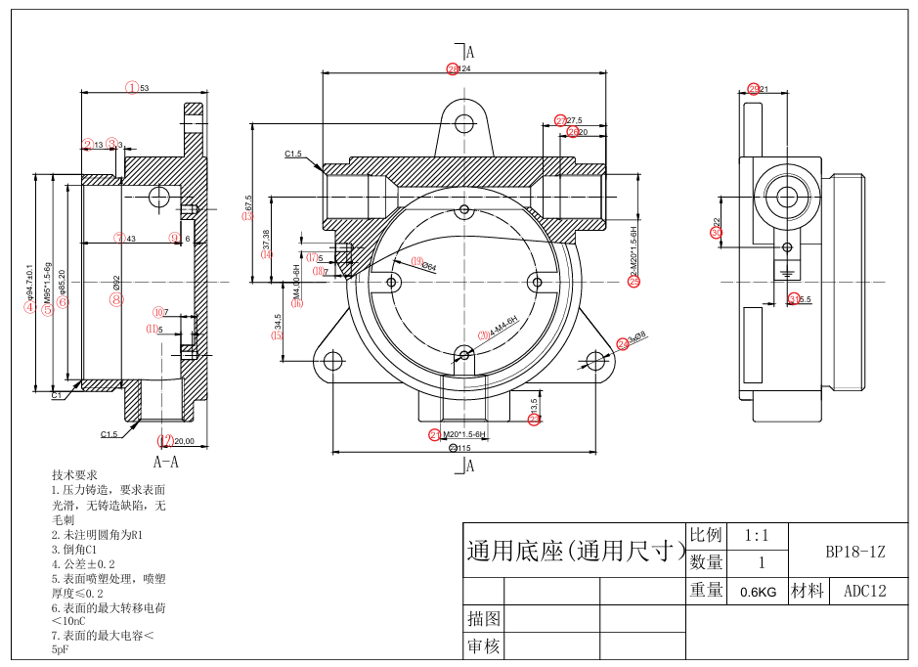

ASSEMBLY DRAWING
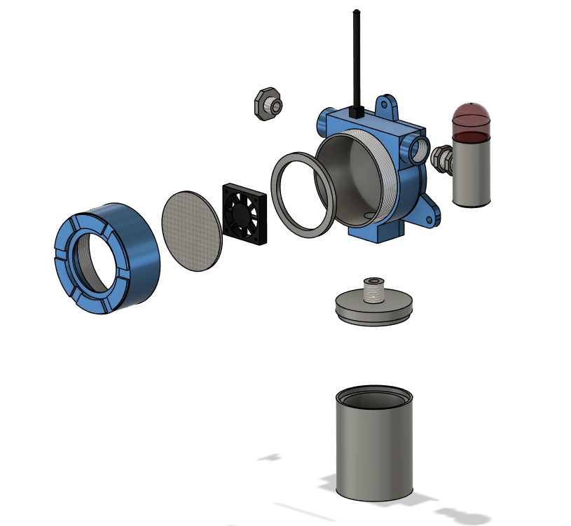
EXPLODED VIEW
STAINLESS WIRE MESH PLATE
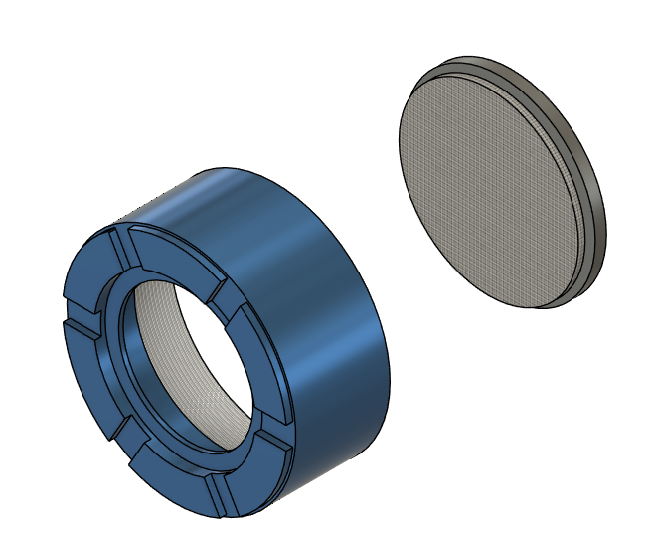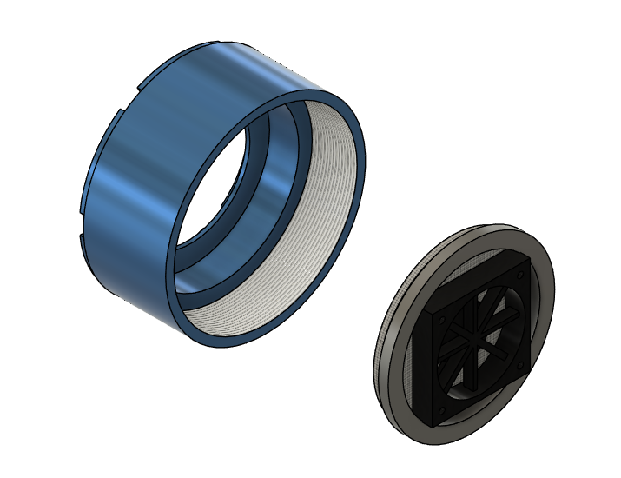
CASING COVER
WIRE MESH
LOCKING BRACKET
DC FAN
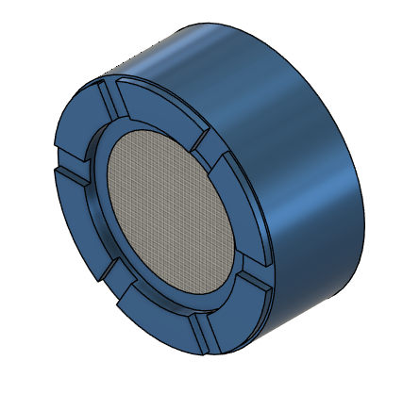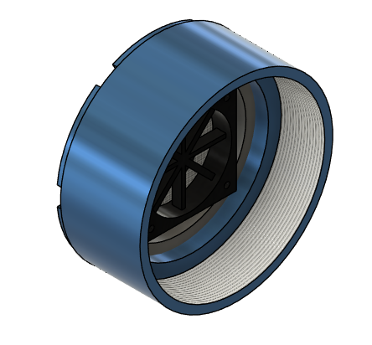
CASING COVER

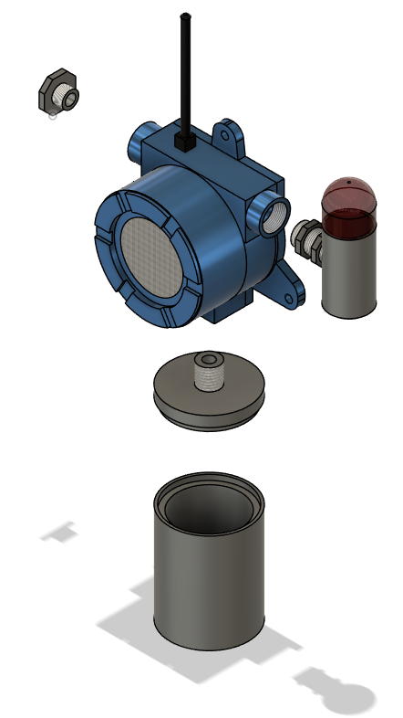
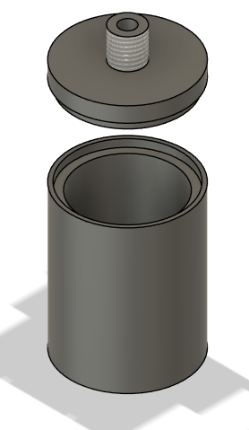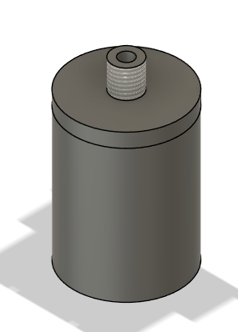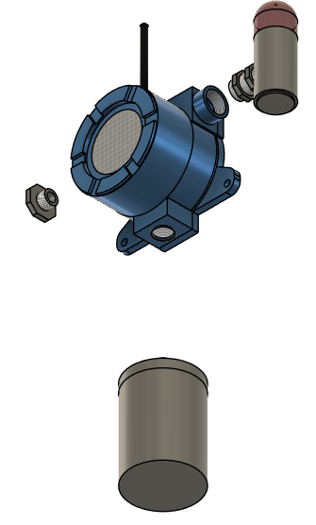
BATTERY CASE

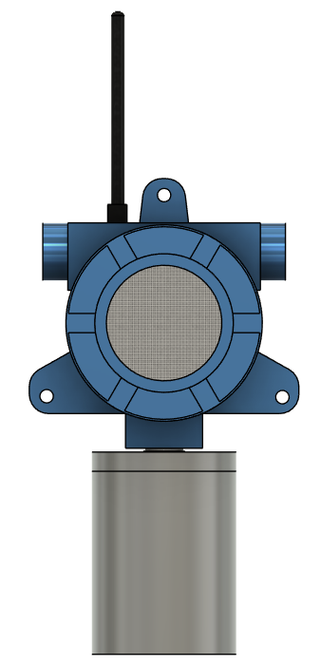
RUBBER GASKET
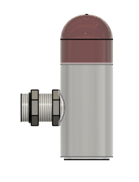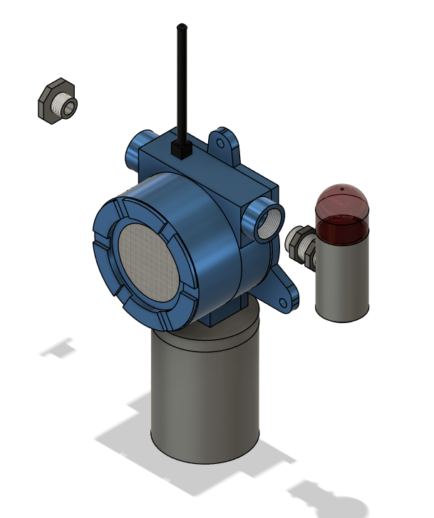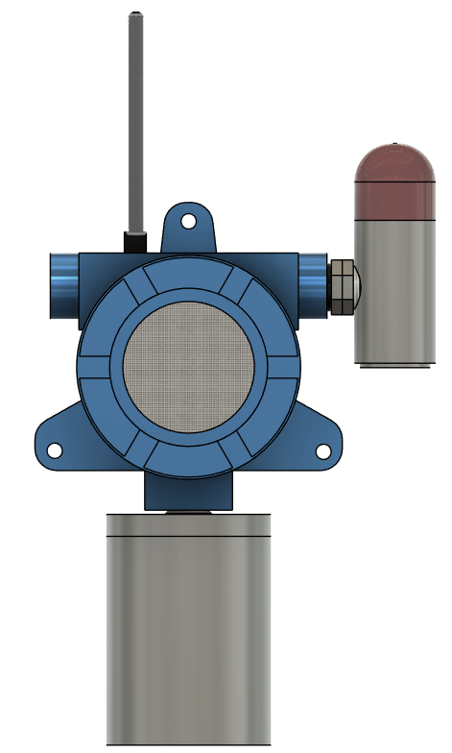
LED & BUZZER

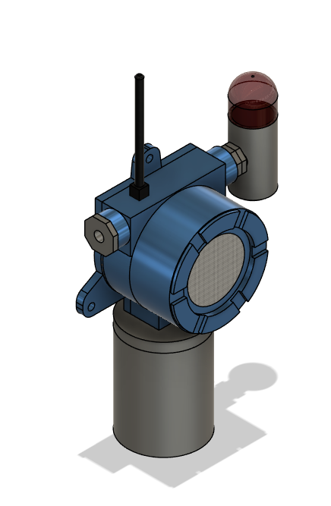
24VDC
POWER IN

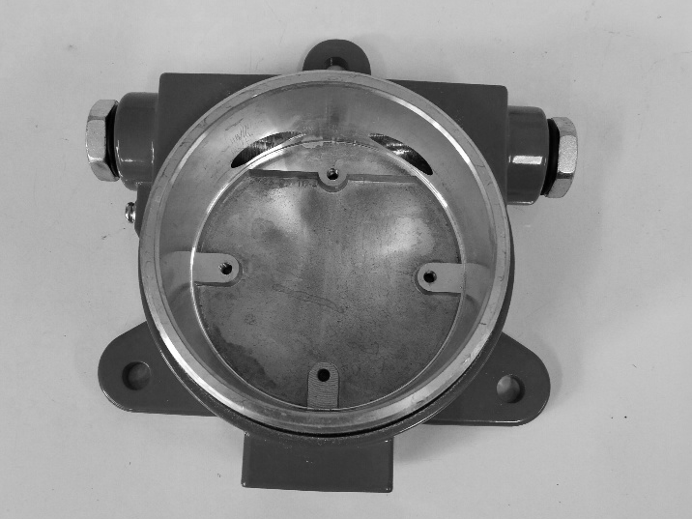
BASE CASING

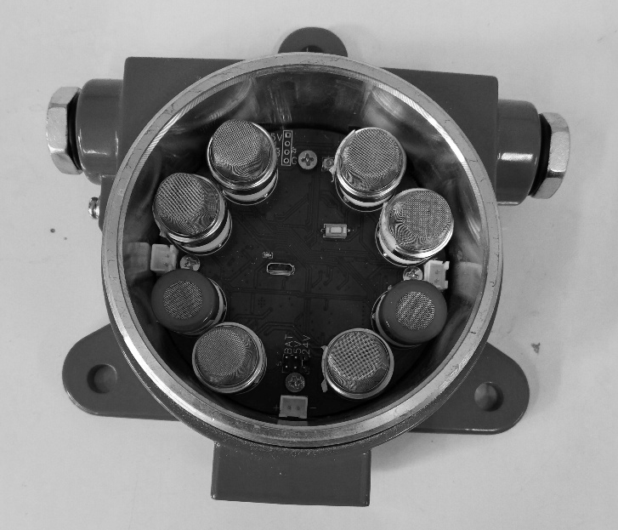
PUT MOTHERBOARD TO BASE CASE

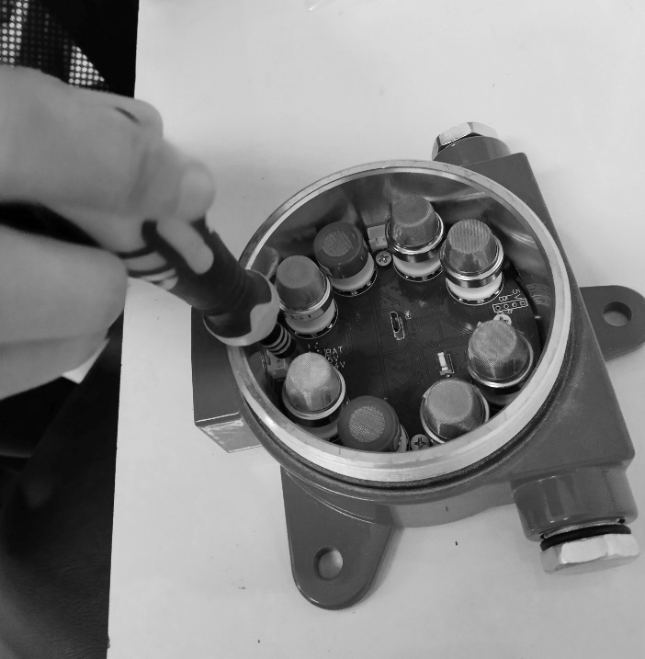
SECURE THE MOTHERBOARD TO THE BASE ENCLOSURE USING THE DESIGNATED MOUNTING SCREWS.
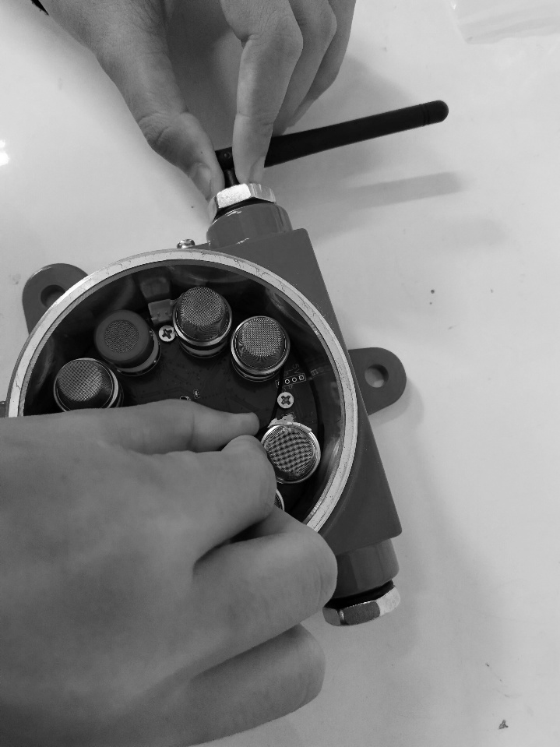
INSTALL THE LORA ANTENNA CABLE.
Note: In the latest version, the LoRa antenna is positioned above the base enclosure rather than on the side. The version currently shown reflects the previous design.


CONNECT THE LED AND BUZZER CABLES.
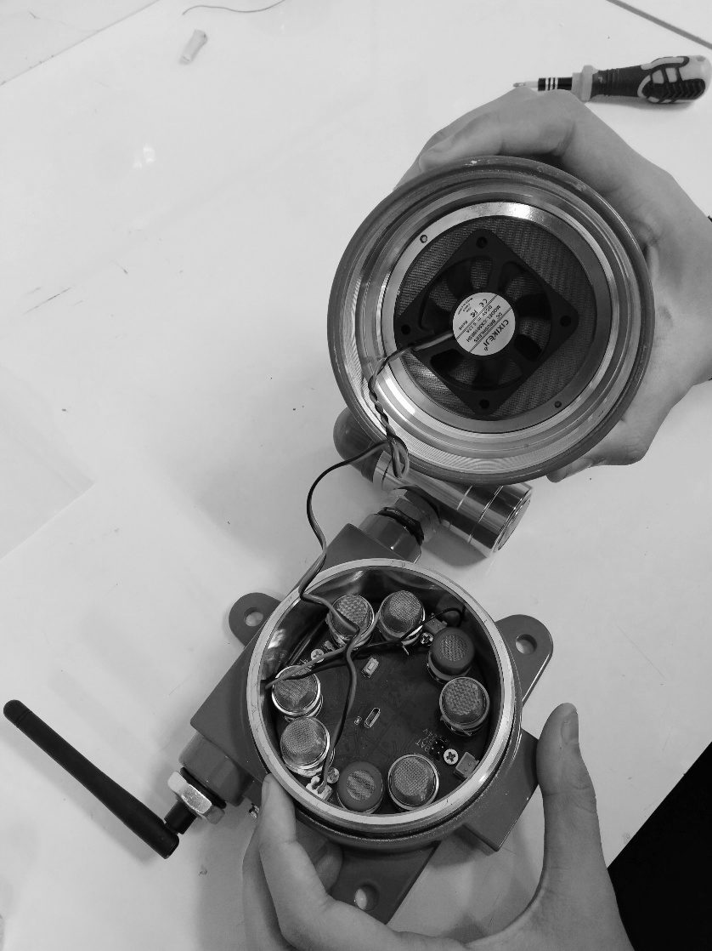
ATTACH THE DC FAN TO THE ENCLOSURE COVER,
BEHIND THE STAINLESS-STEEL WIRE-MESH PLATE.
CONNECT THE DC FAN POWER CABLE TO THE MOTHERBOARD.

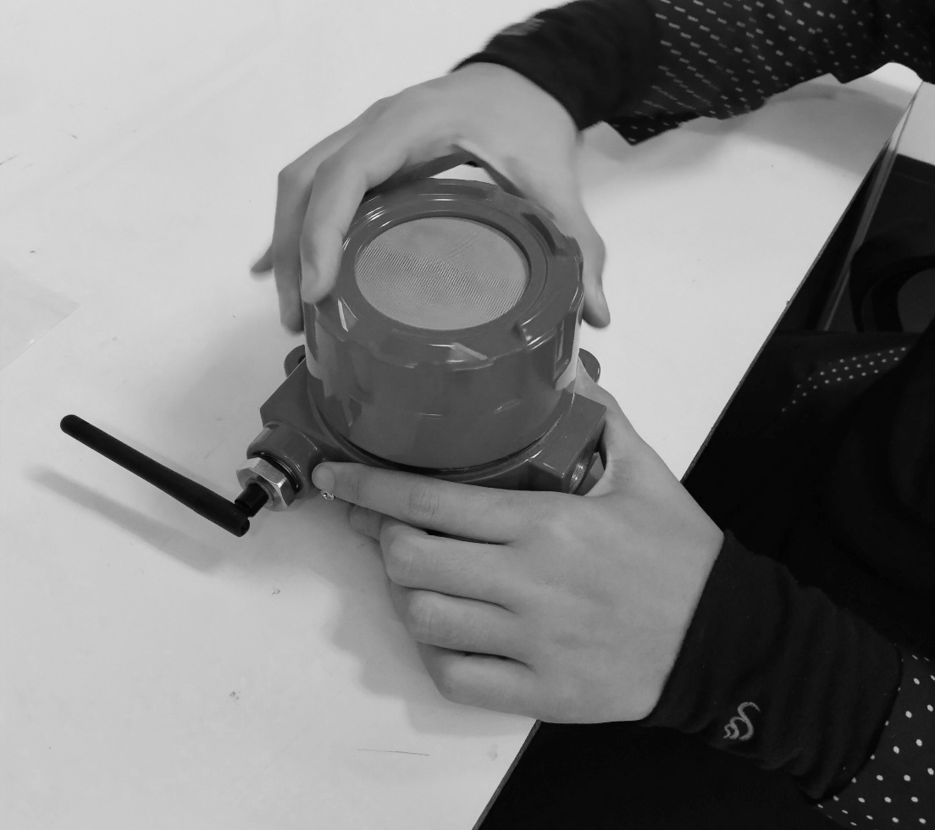
CLOSE THE ENCLOSURE COVER BY TURNING IT CLOCKWISE.

Component Drawing :
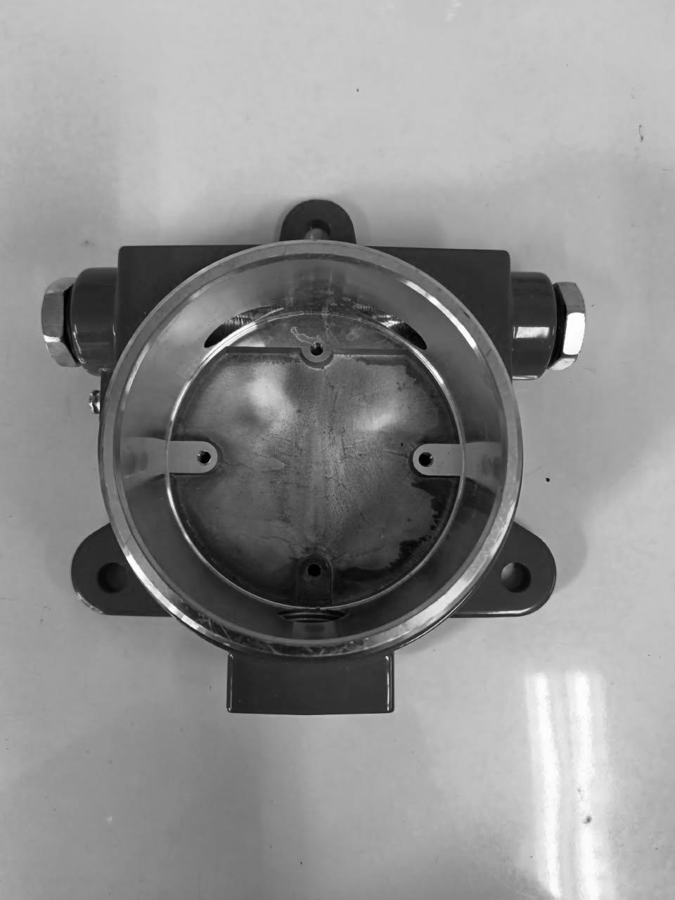 | 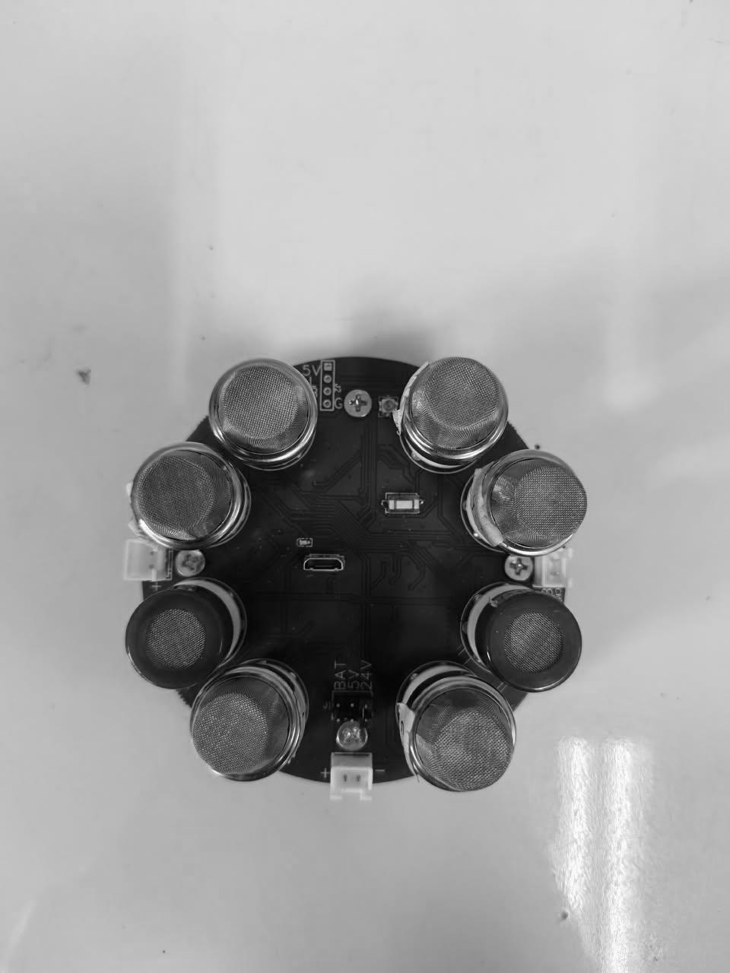
ENCLOSURE | PCB + SENSOR
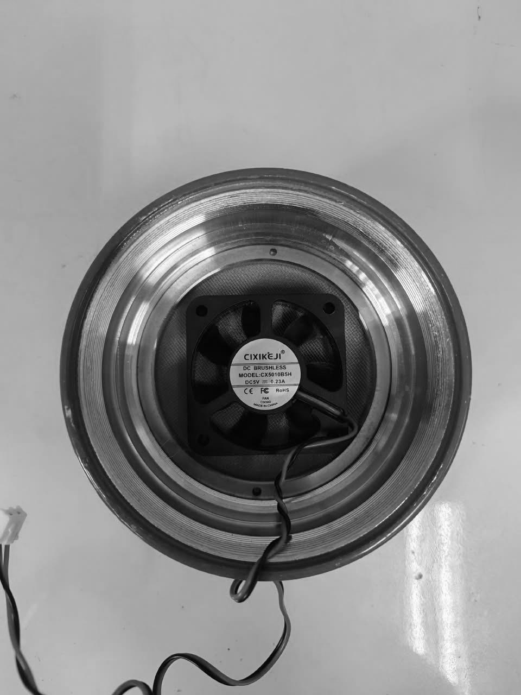 | 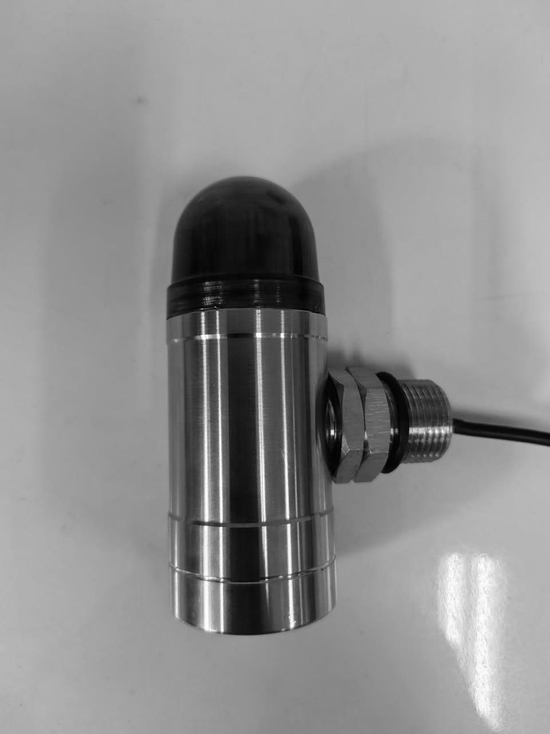
COVER + FAN | ALARM MODULE
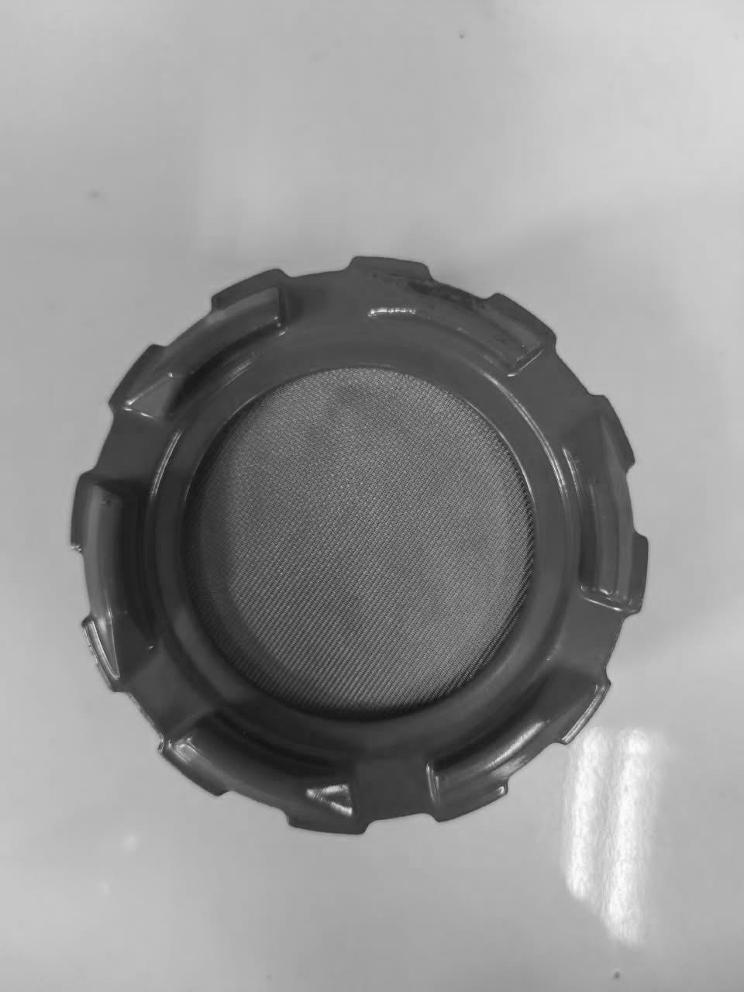 | 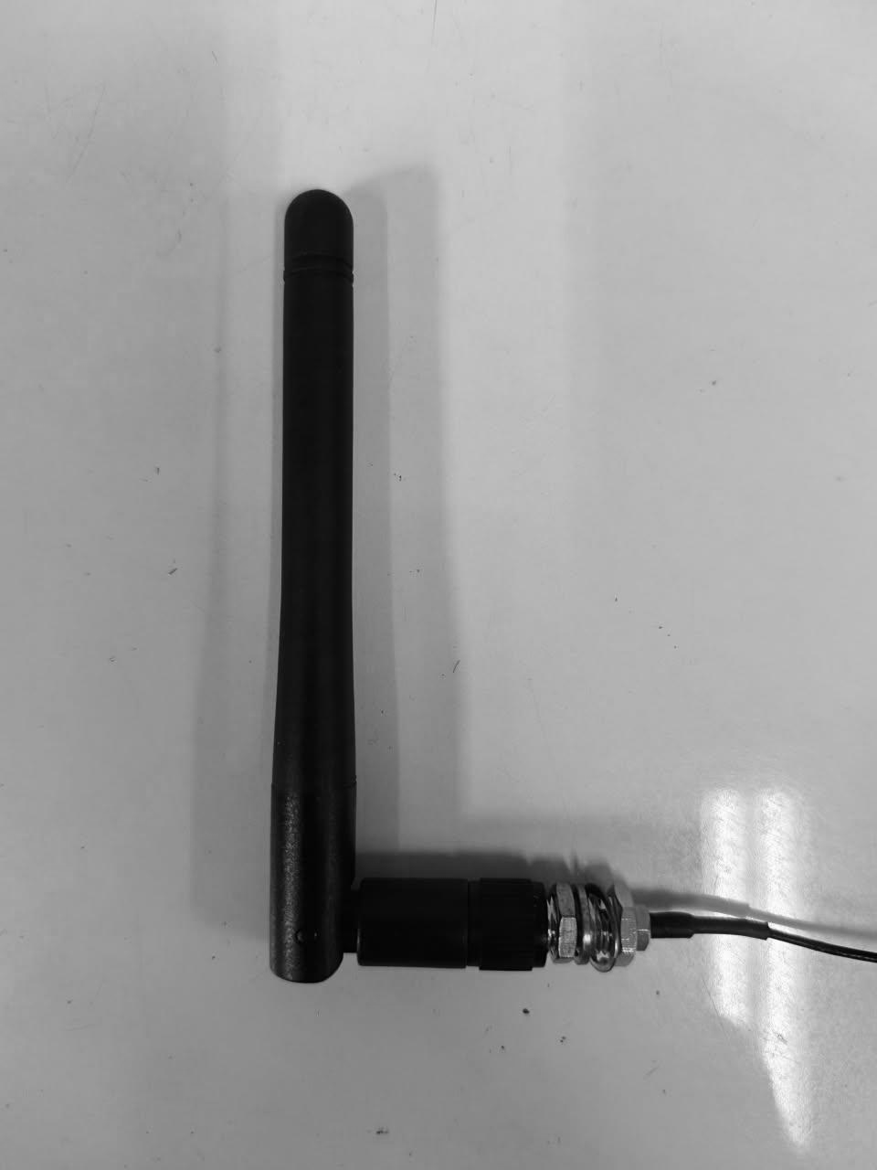
COVER + MESH | ANTENNA 3 DBI

Electrical Schematic :
An electrical schematic capture and a corresponding PCB layout exist for the Gas Leak Detector Main board/ Motherboard .

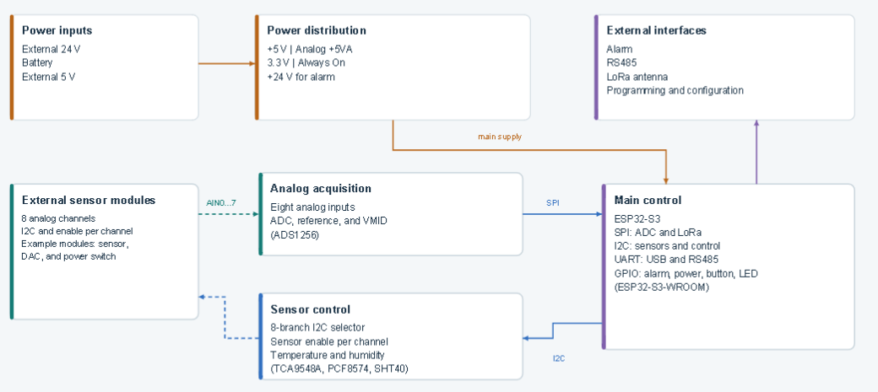

Enclosure Structure :

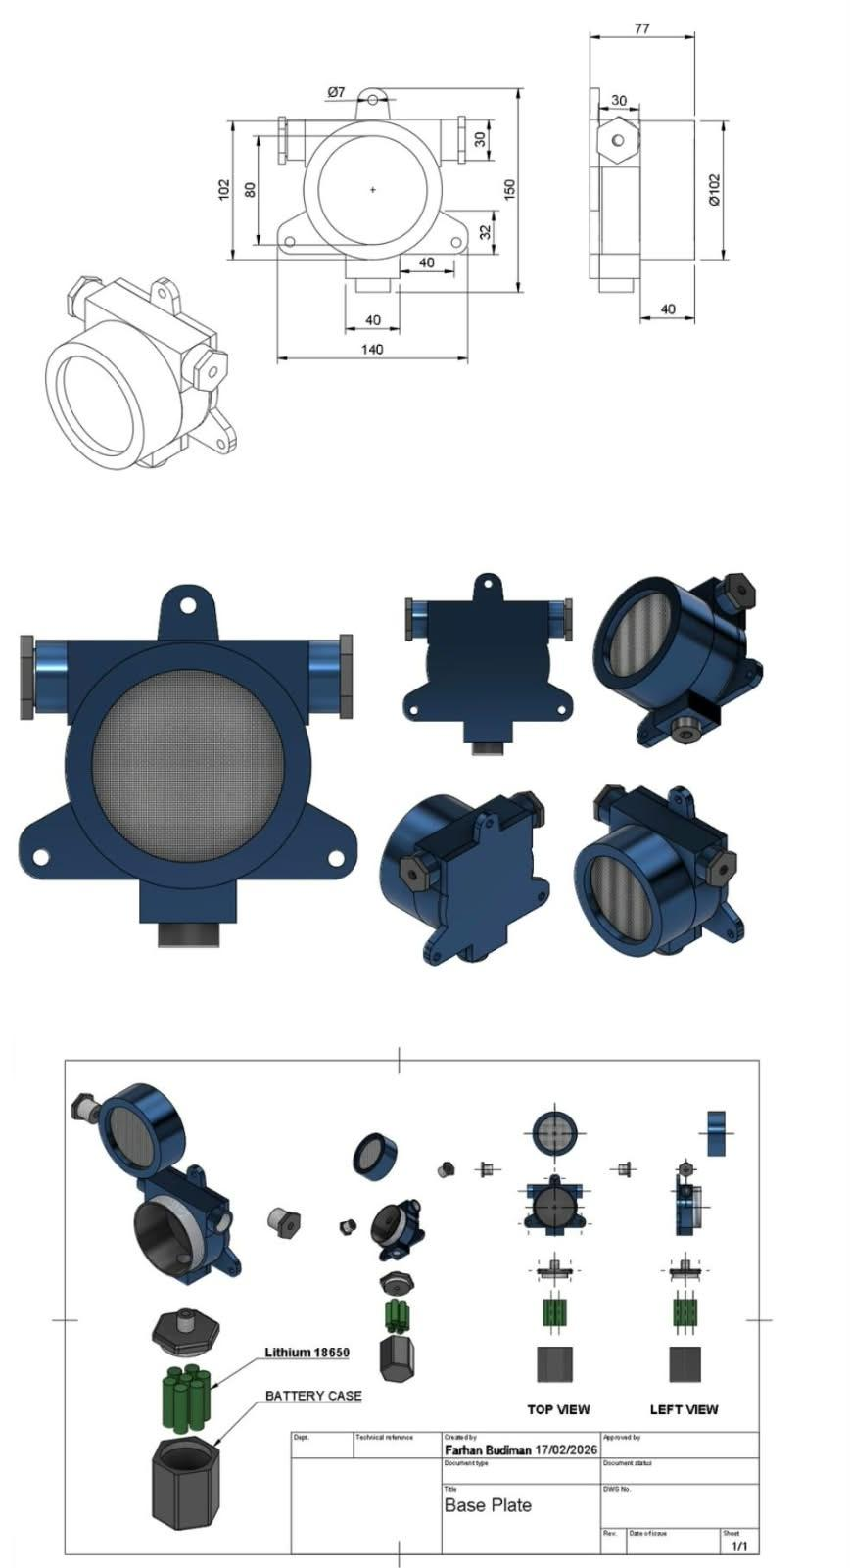

Terminal :

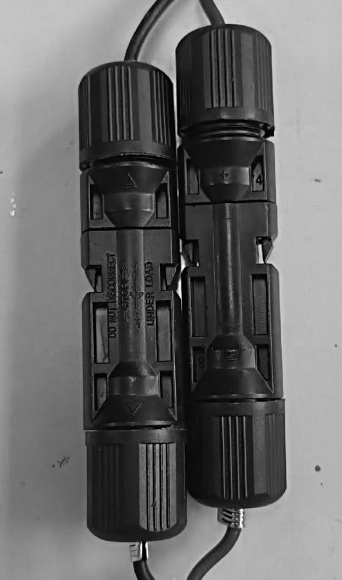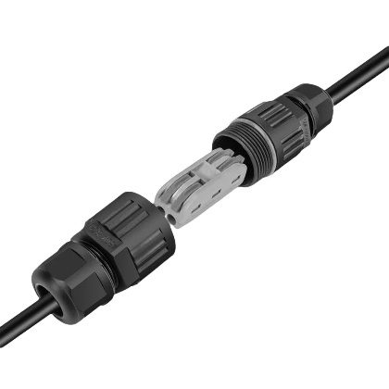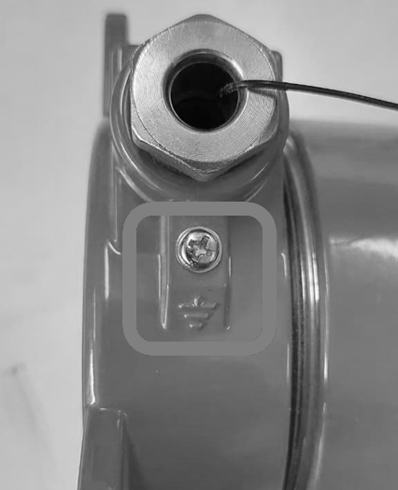
24VDC
WATERPROOF CABLE CONNECTOR
24VDC
POWER IN
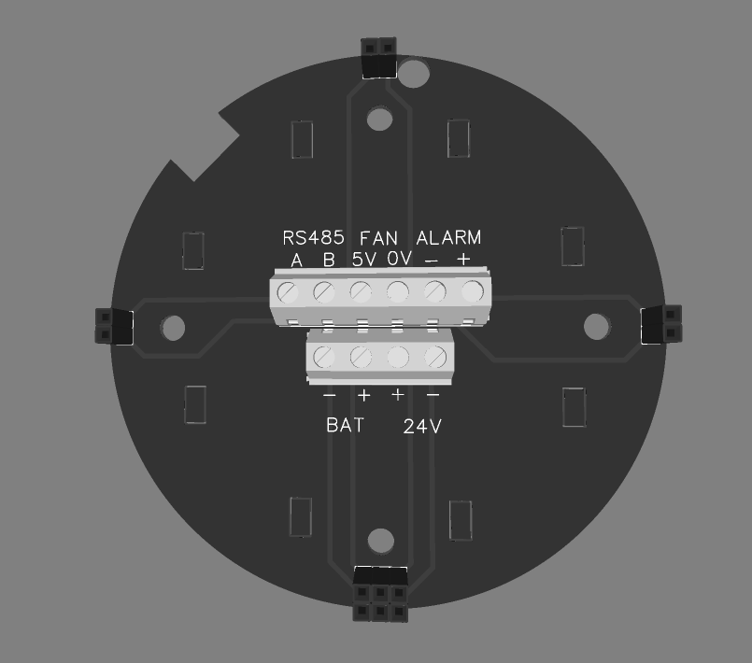
POWER IN
BATTERY OR 24VDC

Grounding :
External grounding stud, marked with the protective earth (ground) symbol, installed on the enclosure body.

- Bill of Materials (BOM) for key components: List all components that affect explosion-proof safety (such as enclosures(gaskets, terminals, cable entry devices, switches, light sources, batteries, potting compounds, plastic parts, printed circuit boards, etc.), including manufacturer, model and specification, material grade (e.g., in compliance with IEC 60079-0 Appendix A), certification information (e.g., existing UL, ATEX, CCC certificates, etc.) or technical parameters (such as CTI value, flame retardancy, chemical resistance, glass transition temperature Tg, etc.);

PCB BOM – Component Summary:
Component | Part / Value | Qty | Manufacturer | MPN
Capacitor | 1 µF | 1 | Samsung | CL21B105KBFNNNE
Capacitor | 100 nF | 2 | Yageo | CC0805KRX7R9BB104
Capacitor | 10 µF | 4 | Murata | GRM21BR61H106KE43L
Capacitor | 33 µF | 2 | TDK | C2012X5R1A336MTJ00E
Capacitor | 47 nF | 1 | Samsung | CL10B473KB8NNNC
Capacitor | 22 nF | 1 | Samsung | CL10B223KB8NNNC
Capacitor | 33 pF | 1 | Samsung | CL10C330JB8NNNC
Capacitor | 100 nF | 2 | Yageo | CC0603KRX7R9BB104
Capacitor | 100 nF | 38 | Samsung | CL05B104KO5NNNC
Connector | XH-2A, Black | 2 | Boomele | XH-2A
TVS Diode | SMBJ33A | 1 | Ruilon | SMBJ33A
Zener Diode | LBZT52C12T1G | 1 | LRC | LBZT52C12T1G
Schottky Diode | BAT54C | 2 | CJ | BAT54C
ESD Protection Diode | LESD5D5.0CT1G | 3 | UMW | LESD5D5.0CT1G
TVS Diode | SM712 | 1 | DOWO | SM712
Schottky Diode | SS54 | 2 | MDD | SS54
Schottky Diode | SK36 | 1 | Good-Ark | SK36
Fuse | MINISMDC260F/16 | 2 | Littelfuse | MINISMDC260F/16-2
RF Connector | U.FL | 1 | — | —
Input Connector | VIN | 1 | — | —
Ferrite Bead | 300 Ω | 1 | TDK | ACM7060-301-2PL-TL01
Inductor | 2.2 µH | 1 | SXN | SMDRH105R-2R2NT
Inductor | 2.2 µH | 1 | APV | ANR3015T2R2M
Ferrite Bead | 100 Ω | 1 | TDK | MPZ2012S101AT000
Inductor | 10 µH | 1 | SXN | SMDRH105R-100MT
LED | 19-217/BHC-ZL1M2RY/3T | 1 | Everlight | 19-217/BHC-ZL1M2RY/3T
Transistor | UMH3NTN | 1 | ROHM | UMH3NTN
MOSFET | AO4407 | 1 | JSMSEMI | AO4407
MOSFET | SI7465DP-T1-GE3 | 1 | Vishay | SI7465DP-T1-GE3
Resistor | 187 kΩ | 1 | UNI-ROYAL | 0603WAF1873T5E
Resistor | 82 kΩ | 1 | UNI-ROYAL | 0603WAF8202T5E
Resistor | 19.1 kΩ | 1 | UNI-ROYAL | 0603WAF1912T5E
Resistor | 1 kΩ | 1 | UNI-ROYAL | 0603WAF1001T5E
Resistor | 56 kΩ | 2 | UNI-ROYAL | 0603WAF5602T5E
Resistor | 189 kΩ | 1 | Yageo | RT0603BRD07189KL
Resistor | 33 kΩ | 1 | UNI-ROYAL | 0603WAF3302T5E
Resistor | 470 Ω | 1 | UNI-ROYAL | 0603WAF4700T5E
Push Button Switch | SKQYAAE010 | 1 | Alps Alpine | SKQYAAE010
Boost Converter IC | TPS61175PWP | 1 | Texas Instruments | TPS61175PWP
Buck Converter IC | LMR51450SDRRR | 1 | Texas Instruments | LMR51450SDRRR
Inductor | 4.7 µH | 1 | ABC | GSSM06304R7M2AU

- Material specification sheets/data sheets: Detailed technical parameters for non-metallic materials (enclosures, seals, insulators, potting compounds, etc.) to prove compliance with standard requirements (such as heat and cold resistance, anti-aging, anti-static, flame retardancy, CTI value, comparative tracking index, chemical resistance, etc.). Provide test reports or conformity declarations from material suppliers;

- Manufacturing process description: Especially for processes that affect explosion-proof safety (such as enclosure processing accuracy control, explosion-proof surface treatment, welding process, potting process, die-casting process, bonding process, etc.);
- Explosion-proof related calculations and explanations (if applicable);
- Temperature group calculation (estimation of the hottest point temperature);

- Usage and installation instructions (draft):
  - Clear safety warnings;
- Only trained and authorized personnel may install, commission, operate, inspect, or maintain the detector.
- Isolate and verify the 24 VDC supply before opening the enclosure or changing wiring. Apply the site lockout/tagout procedure.
- Use only the approved production power arrangement: 24 VDC.
- Do not open the enclosure while an explosive atmosphere may be present unless the equipment is de-energized and the area is confirmed gas-free.
- Perform alarm tests with appropriate site controls and hearing protection where audible devices are connected.
- Perform sensor nulling only in confirmed clean air. Accept the operation only when all eight sensors report a complete 8/8 result; otherwise correct the cause and repeat.
- Do not drill, weld, enlarge cable entries, bypass protective devices, or modify the enclosure without written engineering and Ex approval — any unauthorised modification to an approved enclosure invalidates the certificate.
- Remove the unit from service if there is visible damage, water ingress, an unresolved sensor fault, failed alarm proof, or a loss of protective-earth continuity.

  - Detailed installation requirements (such as cable entry method, torque requirements, grounding requirements, cleaning requirements);

Cable Entry Method :
Use only cable glands, adaptors, blanking elements, and seals approved for the final protection concept, certificate, thread form, IP rating, cable outer diameter, and installation temperature. Do not create new entries, enlarge an entry, leave unused entries open, or substitute a general-purpose gland. Maintain the manufacturer sealing and clamping sequence. Record the installed component part number and certificate reference. Threaded covers/entries must be engaged to the minimum number of full threads specified by the enclosure certificate before the locking element is applied.
Cable Gland Selection Guide
Hazardous Area | Required Gas Group | Recommended Cable Gland Type
Zone 1 / Zone 21 | IIC | Ex d barrier gland required
Zone 2 / Zone 22 | IIA / IIB | Any suitable Ex d gland permitted

Torque Requirements :
Torque values shall comply with the approved enclosure, terminal, cable-gland, and blanking-plug manufacturer instructions.
Grounding Requirements :
Connect the enclosure to the approved protective-earth system using the designated grounding terminal. Verify continuity before energization.
Cleaning Requirements :
- For routine cleaning, isolate the equipment as required by site procedure and use a soft lint-free cloth lightly dampened with clean water or an approved mild cleaner.
- Do not use abrasives, aggressive solvents, dry compressed air, high-pressure spray, or tools that can damage the enclosure, gasket, label, antenna, or cable entries. Keep liquid out of all openings.

  - Operating instructions, maintenance requirements (frequency, content, precautions);

Operating Instructions :
Mode | Purpose | Use restriction
Inference | Normal gas-class inference and alarm operation | Production operating mode after commissioning
Dataset | Engineering / data-collection activity | Not a substitute for approved detection operation
Nulling | Sensor baseline / calibration activity | Clean air only; perform under approved procedure; require complete 8/8 result
- Before each operating period, check power, enclosure condition, diagnostic status, communication status, and the absence of active faults.
- Treat an alarm as a real process-safety event until the site response procedure establishes otherwise.
- If the detector reports a fault or loses required communication, notify the responsible operator and place the affected detection point in the site impairment process.
- Do not change firmware, model files, alarm thresholds, or calibration parameters from the field without controlled approval and a documented rollback path.

Periodic Inspection & Maintenance Schedule
Interval | Activities
Daily / Each Shift | Check power supply, enclosure condition, diagnostic status, LoRa communication status, and ensure there are no active faults.
Every 3 Months | Perform visual inspection of the sensor and protective mesh. Applicable particularly to electrochemical/catalytic gas sensors, including MQ-type sensors that use chemical sensing elements and heaters.
Every 6 Months | Perform alarm function testing (visual/audible), sensor recalibration/nulling, and visual inspection of flame paths and cover threads for signs of corrosion or damage.
Annually (Minimum) | Conduct a comprehensive inspection, including grounding continuity verification, cable gland and terminal torque checks, gasket/seal condition assessment, and evaluation of sensor element service life for replacement planning.

- Nameplate information (must include all ATEX required marking information)；
Proposed ATEX Nameplate Marking
The equipment nameplate shall include all applicable ATEX and hazardous-area identification information, including:
- ATEX Equipment Category: II 2 G D
- Gas Protection: Ex db IIC T4 Gb
- Dust Protection: Ex tb IIIC T135°C Db
- Ambient Temperature: Tamb = −40°C to +85°C
- CE Marking and Notified Body Number
- Equipment identification / model
- Manufacturer name and/or identification
- Certificate number
The proposed protection marking is based on the reference flame detector documentation, which specifies II 2 G D, Ex db IIC T4 Gb, Ex tb IIIC T135°C Db, Tamb −40°C to +85°C.

- Ex components ATEX certificates

Proposed ATEX Certification

The proposed equipment certification shall meet the following hazardous-area protection classification:

II 2 G D
Ex db IIC T4 Gb
Ex tb IIIC T135°C Db
Tamb = −40°C to +85°C

The selected Ex components, including the flameproof enclosure, cable glands, and other applicable Ex-certified components, shall have valid certificates appropriate to the intended hazardous-area classification.

For reference, the source document identifies the flame detector enclosure as ATEX Category II 2 G D, with Ex db IIC T4 Gb and Ex tb IIIC T135°C Db, and references ATEX certification under Directive 2014/34/EU.

- Sample Information:
- Provide the model, serial number, and status (such as whether it can be powered on and run) of the sample;

Model | GLD_V2
Serial Number | GLD2-0x1001
Status | Inference / Normal Operation

- Provide necessary test fixtures or auxiliary equipment.

Equipment | Purpose
Regulated 24 VDC power supply | Provides a stable 24 VDC supply to the GLD during commissioning and functional testing.
Digital multimeter | Measures the actual voltage, verifies polarity and continuity, and supports grounding/bonding verification.
Calibrated gas source / gas test kit | Provides the required gas types to verify that the sensors respond correctly when exposed to the target gases.
Gas test chamber | Provides a controlled gas-exposure environment so that gas concentration, exposure time, and test conditions can be reproduced.
Alarm load / relay simulator | Physically verifies that the alarm output and connected electrical load operate correctly.
LoRa peer / gateway | Verifies that data transmitted by the GLD is successfully received by the intended system.
Laptop and approved software | Used to review diagnostic information, configuration, logging, firmware identification, and to store commissioning and test evidence.
Calibrated torque screwdriver | Ensures that glands, terminals, enclosure fasteners, and grounding connections are tightened to the approved torque values.
ECEx/ATEX 认证信息提供要求

1. 基本资料 (申请与组织):
- 申请表 (由ExCB提供模板)。
- 制造商营业执照/公司注册证明。
- 制造商组织结构图、联系信息。
- 制造工厂地址、生产设施简介。
- (如适用) ISO 9001 证书及质量手册、程序文件目录 (用于QAR评审)。

2. 技术文件 (核心):
- 产品详细描述：
- 产品名称、型号、规格清单。
- 完整、清晰的功能描述和技术参数（电气参数、机械参数等）。
- 清晰的产品照片（整体和关键部件）。
- 预期用途和安装环境描述（如适用气体组别IIC/IIB/IIA，温度组别T1-T6，环境温度范围，区域划分0/1/2或20/21/22）。
- 设计与制造信息：
  - 完整的图纸： 总装图、部件图、电路图、电气原理图、PCB布局图（如适用）、外壳结构图（需标明关键隔爆参数如间隙、长度、容积）、接线盒图、端子图、接地连接图等。图纸需清晰标注尺寸、公差、材料。
  - 关键部件清单 (BOM)： 列出所有影响防爆安全的零部件（如外壳、衬垫、端子、电缆引入装置、开关、光源、电池、灌封胶、塑料件、印制电路板等），包括制造商、型号规格、材料等级（如符合IEC 60079-0附录A）、认证信息（如已有UL, ATEX, CCC等证书）或技术参数（如CTI值、阻燃等级、耐化学性、玻璃化温度Tg等）。
  - 材料规格书/数据表： 特别是非金属材料（外壳、密封件、绝缘件、灌封胶等）的详细技术参数，证明其符合标准要求（如耐热耐寒、抗老化、抗静电、阻燃性、CTI值、相比漏电起痕指数、耐化学腐蚀性等）。提供材料供应商的测试报告或符合性声明。
  - 制造工艺描述： 特别是对防爆安全有影响的工艺（如外壳加工精度控制、隔爆面处理、焊接工艺、浇封工艺、压铸工艺、粘接工艺等）。
  - 防爆相关计算与说明 (如适用)：
  - 温度组别计算（最热点温度估算）。
  - 使用与安装说明 (草案)：
    - 清晰的安全警告。
    - 详细的安装要求（如电缆引入方式、扭矩要求、接地要求、清洁要求）。
    - 操作说明,维护要求（周期、内容、注意事项）。
  - 铭牌信息（需包含所有IECEx要求的标志信息）。
  - 防爆元器件ATEX证书

- 样品信息：
  - 提供样品的型号、序列号、状态（如是否可通电运行）。
  - 提供必要的测试工装或辅助设备。

